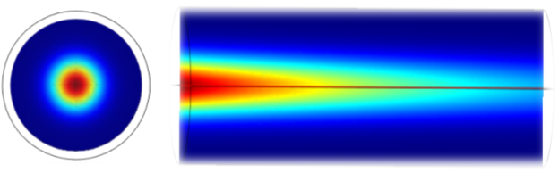

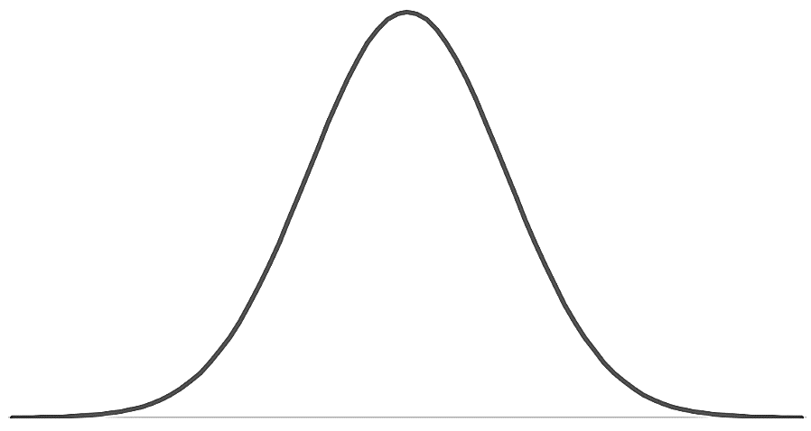

Temperature Peak

Heat

Heat

Heat

Heat

Heat

Heat

Heat

Heat

Heat

Heat